Experiment 1

Exploration of Weka Tool for Breast Cancer Data Classification using different ML modules

Linear Regression Model (

Full training Set with 10 fold cross validation)   
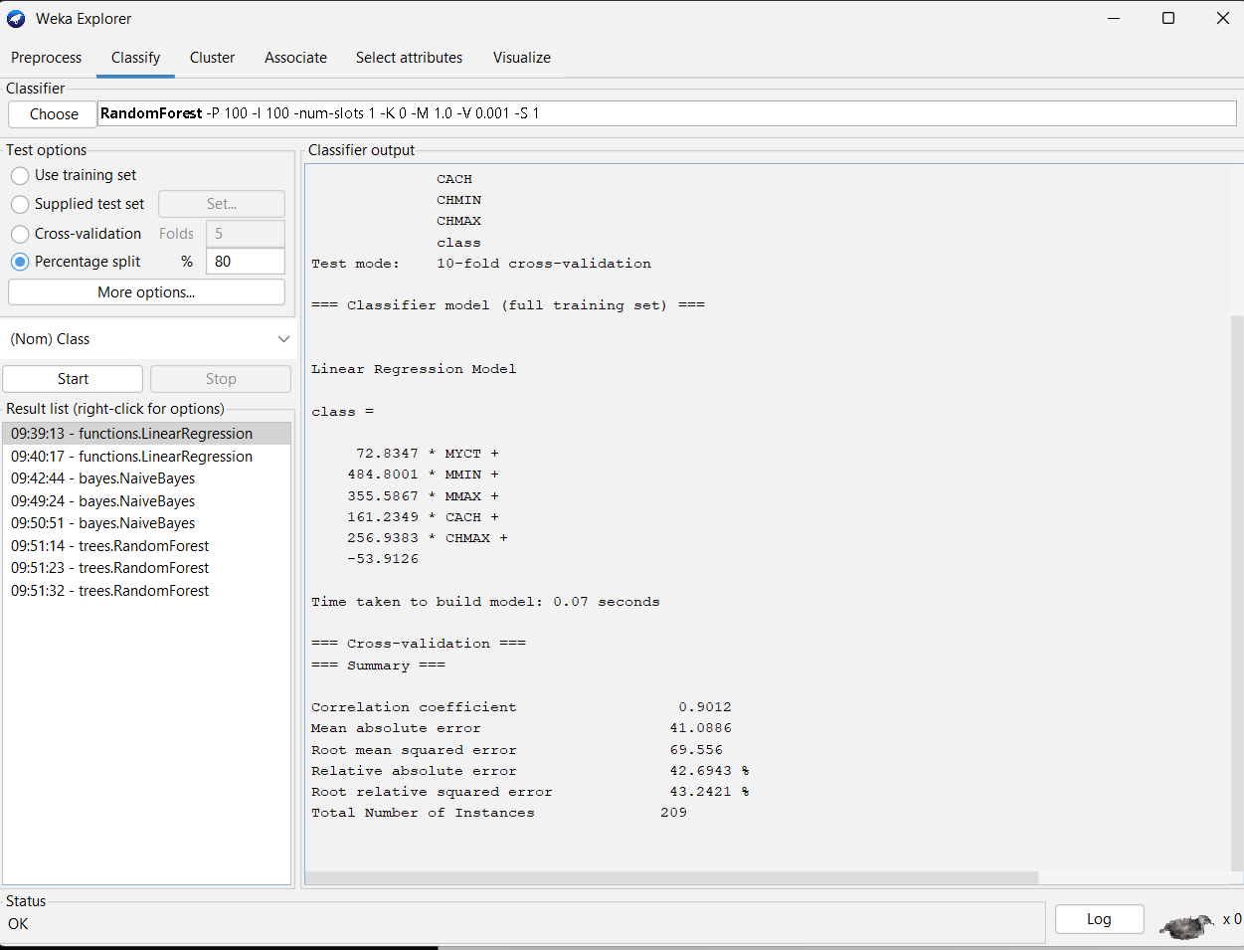3

Linear Regression Model (Full training set with 5 fold cross validation)  
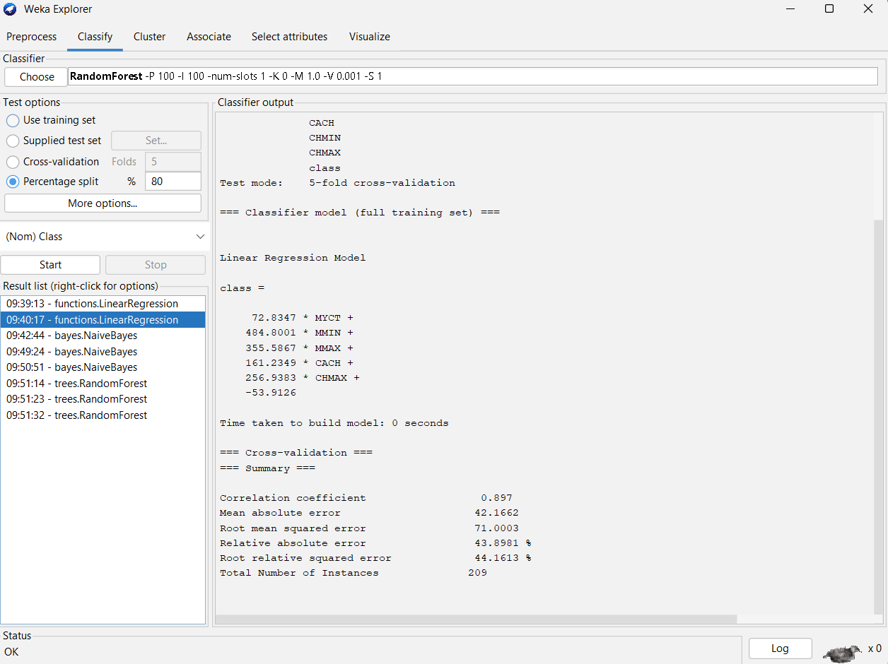

Linear Regression Model 80% Split

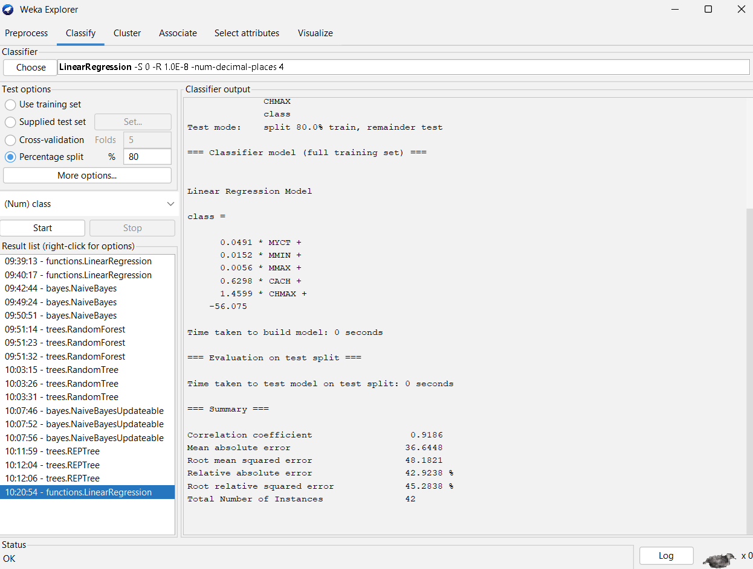

Bayes Naive

Test mode 10 cross validation

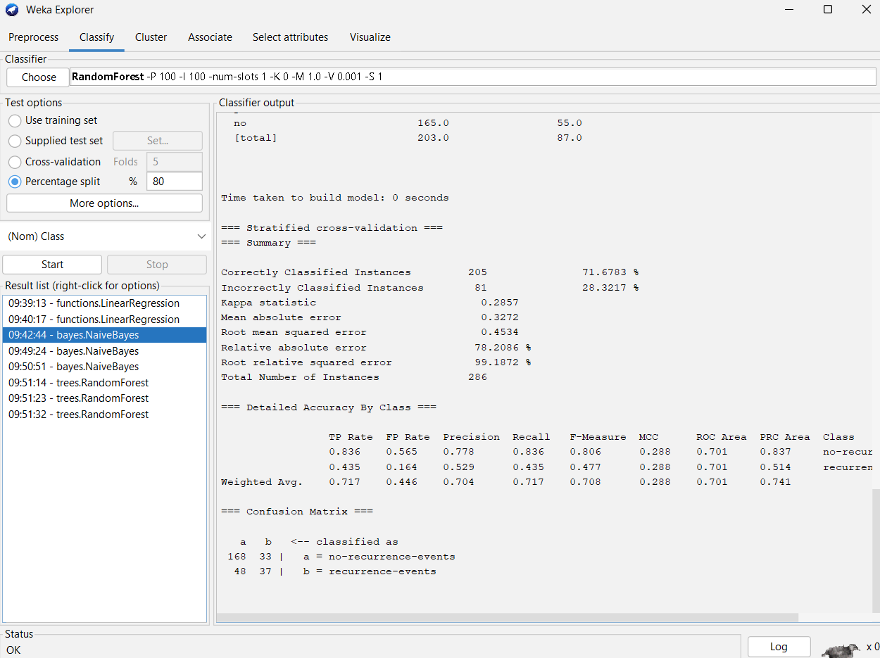

Bayes Naïve 5 cross validation   
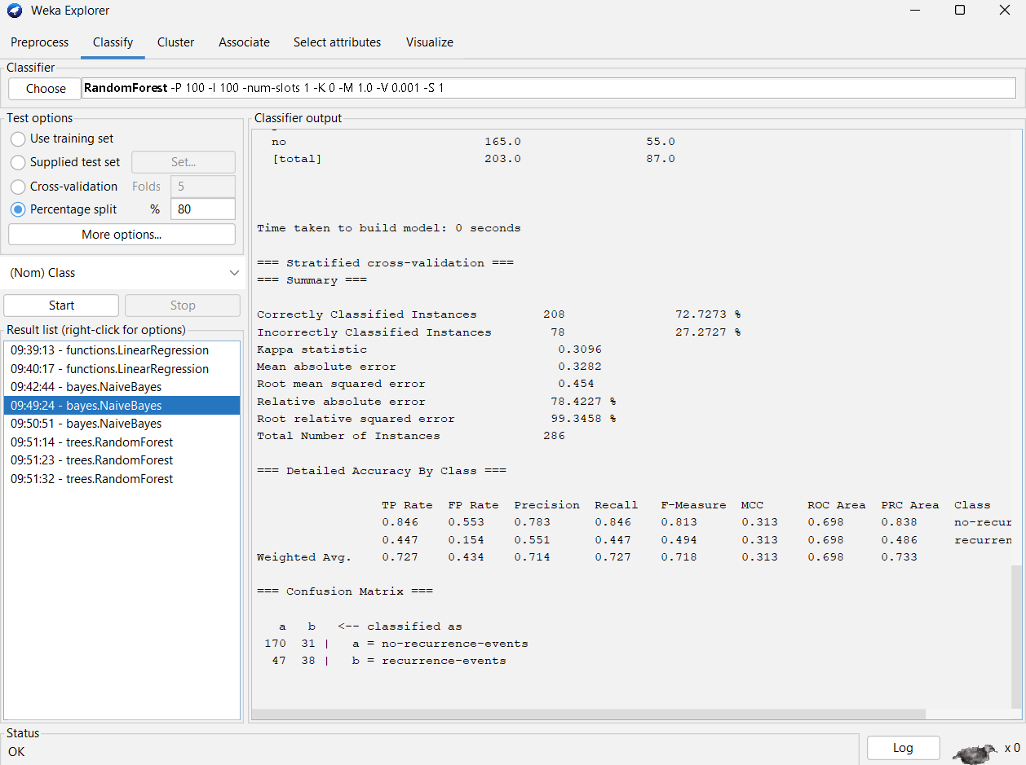

Bayes Naïve split train 80%  
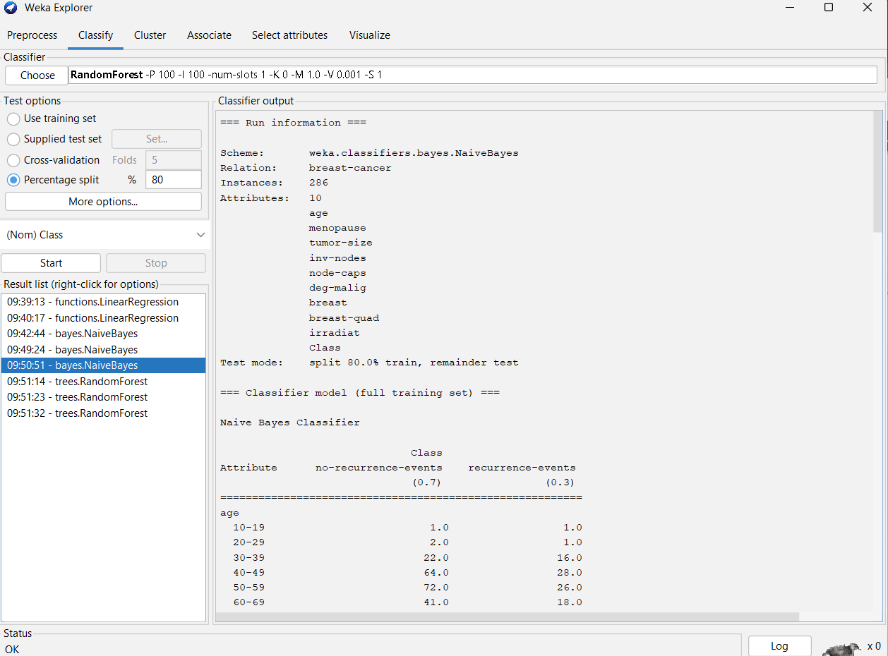

Random Forest Trees 10 Cross Validation   
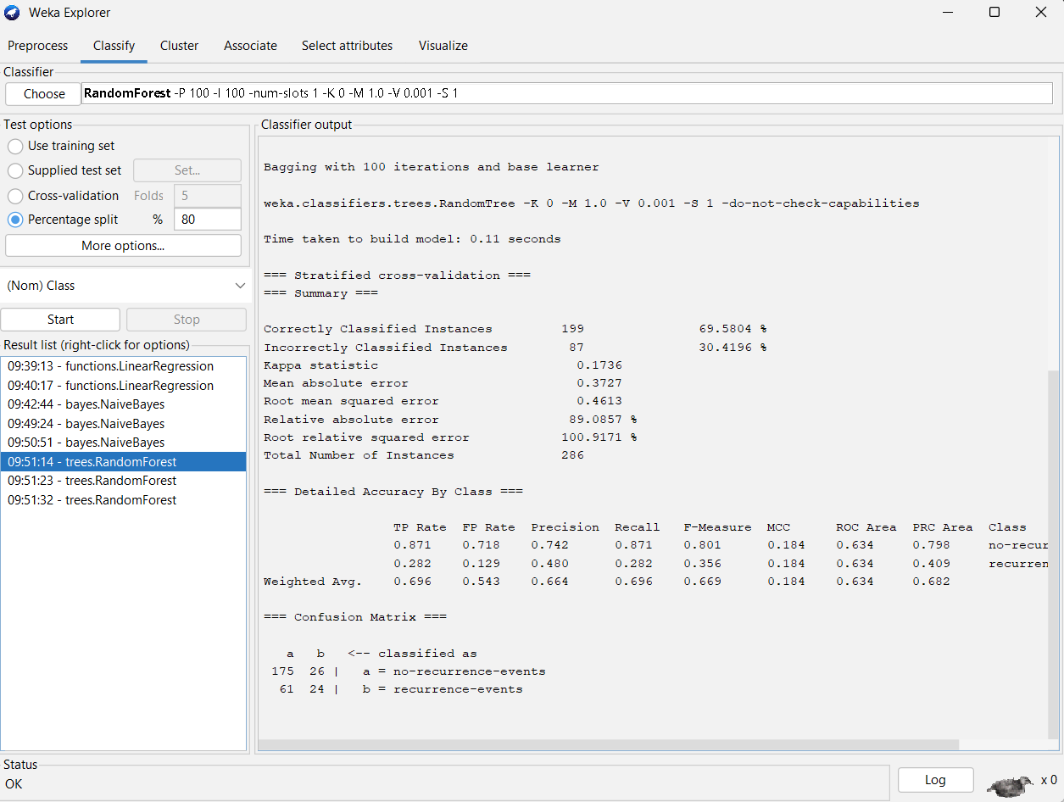

Random Forest Trees 5 cross validation

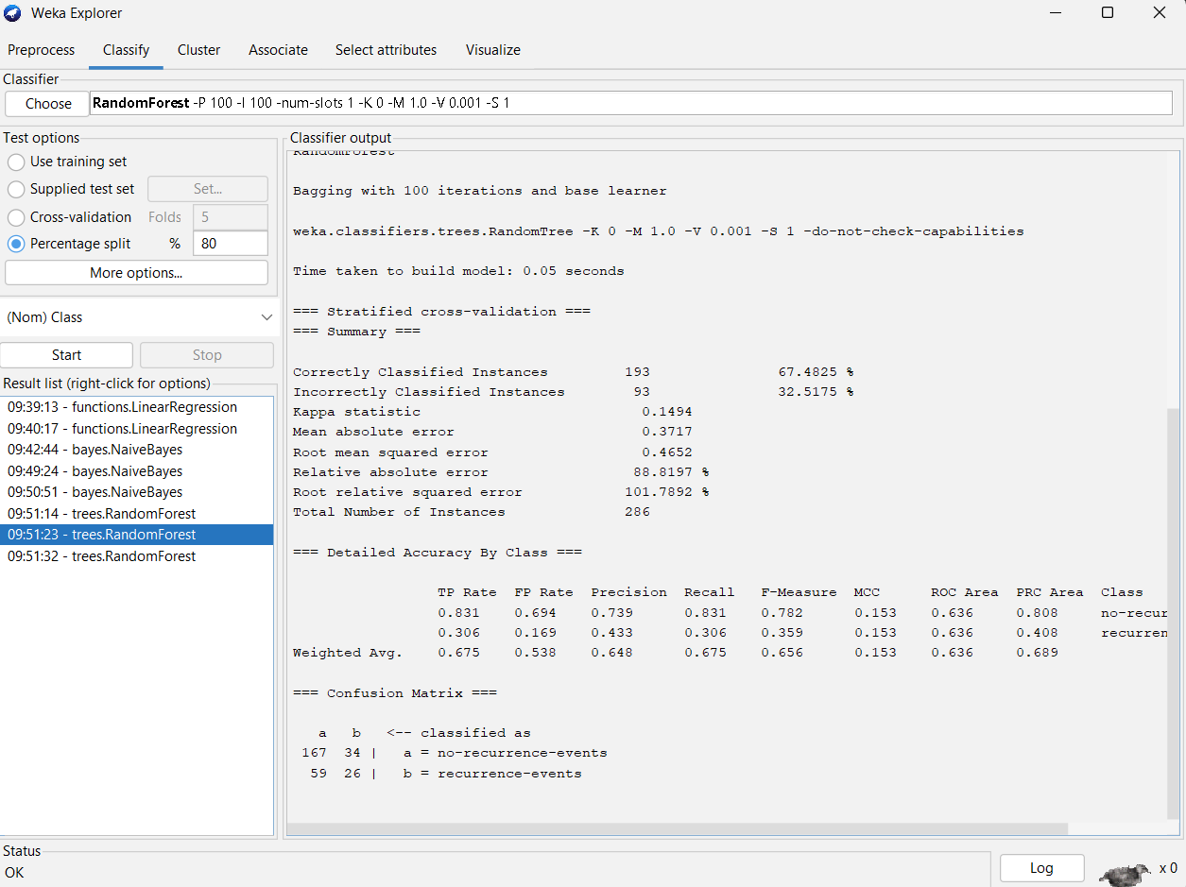

Random Forest Trees 80% percentage split

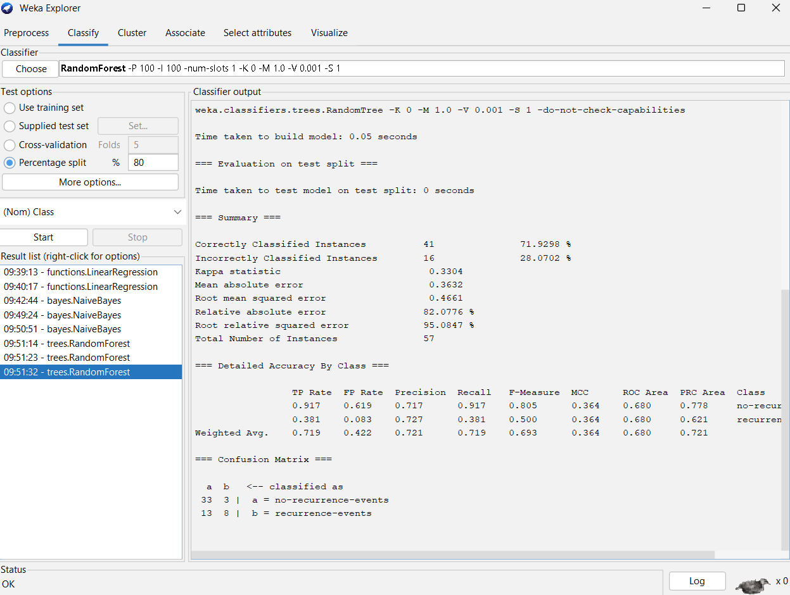

Random Trees 10 Cross Validation



Random 5 Cross Validation

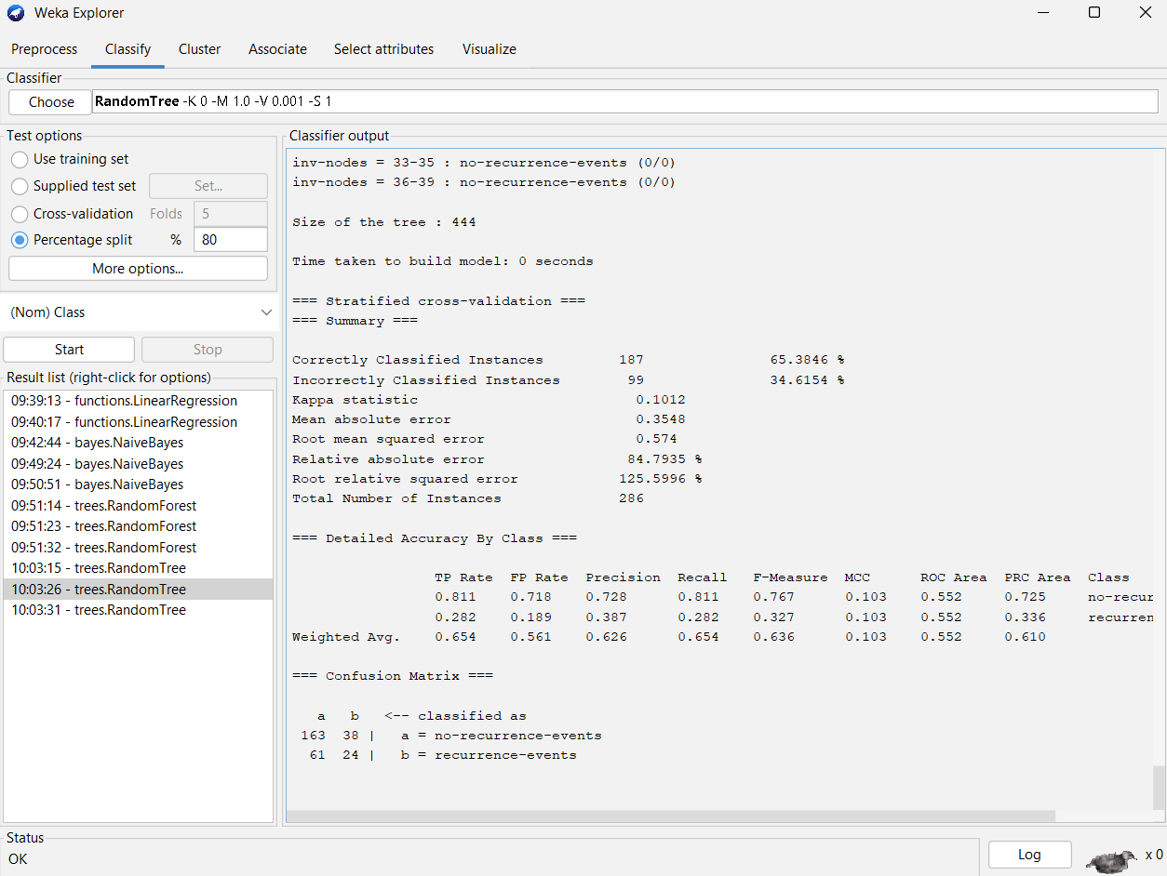

Random Trees 80% split

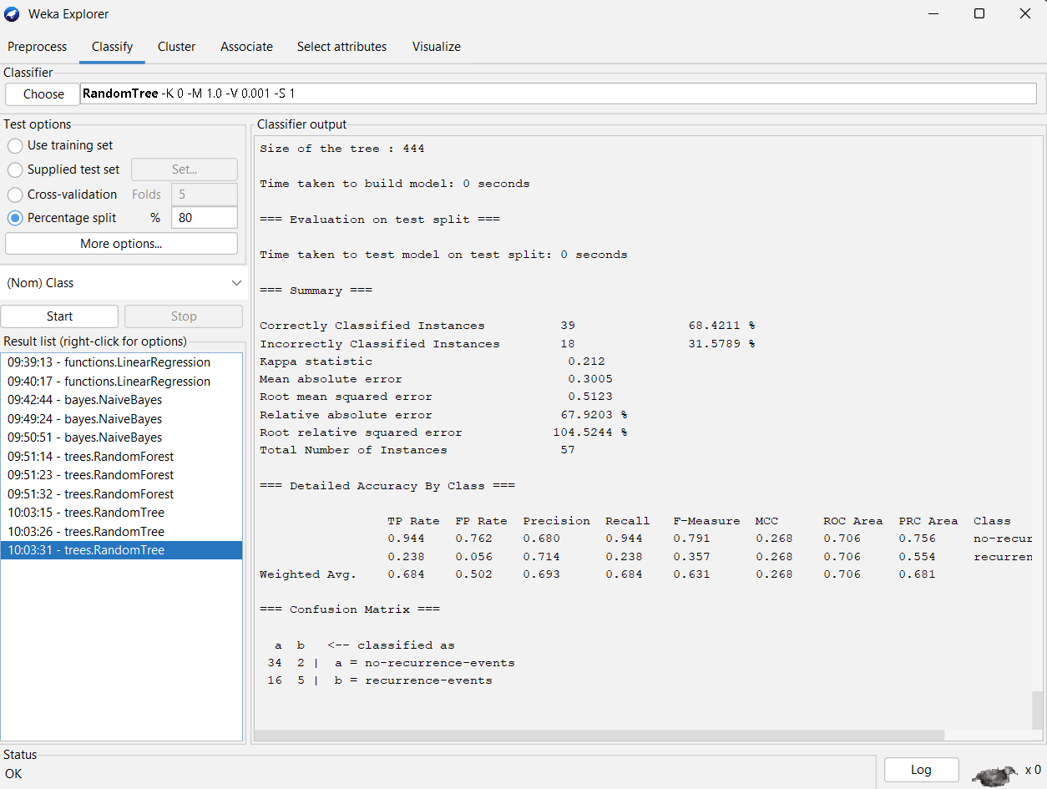

Naïve Bayse Updatable 10 cross validation

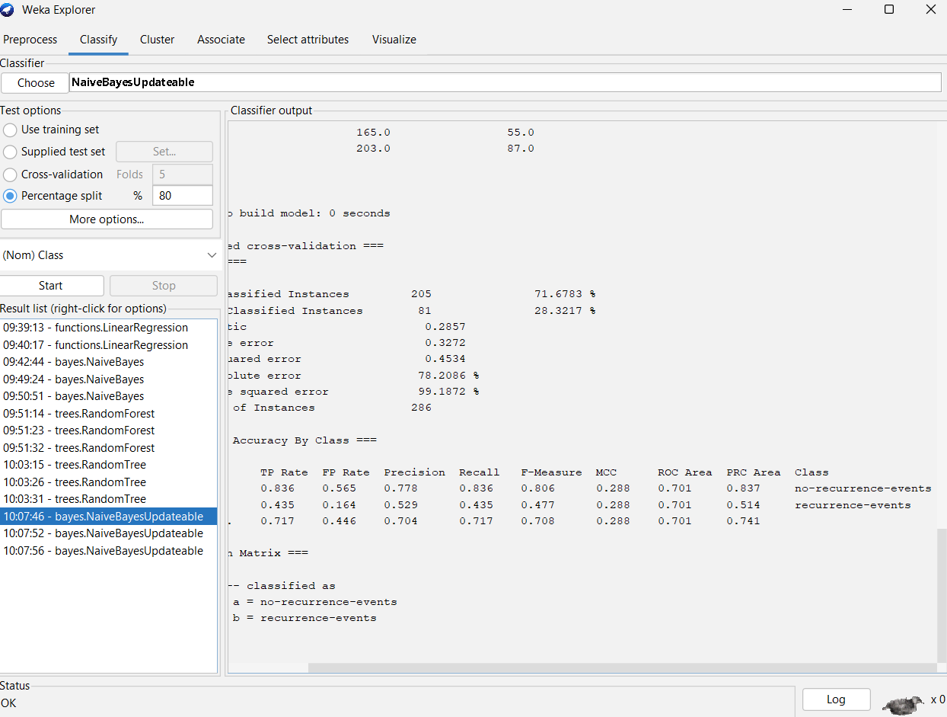

Naïve Bayse Updatable 5 cross validation

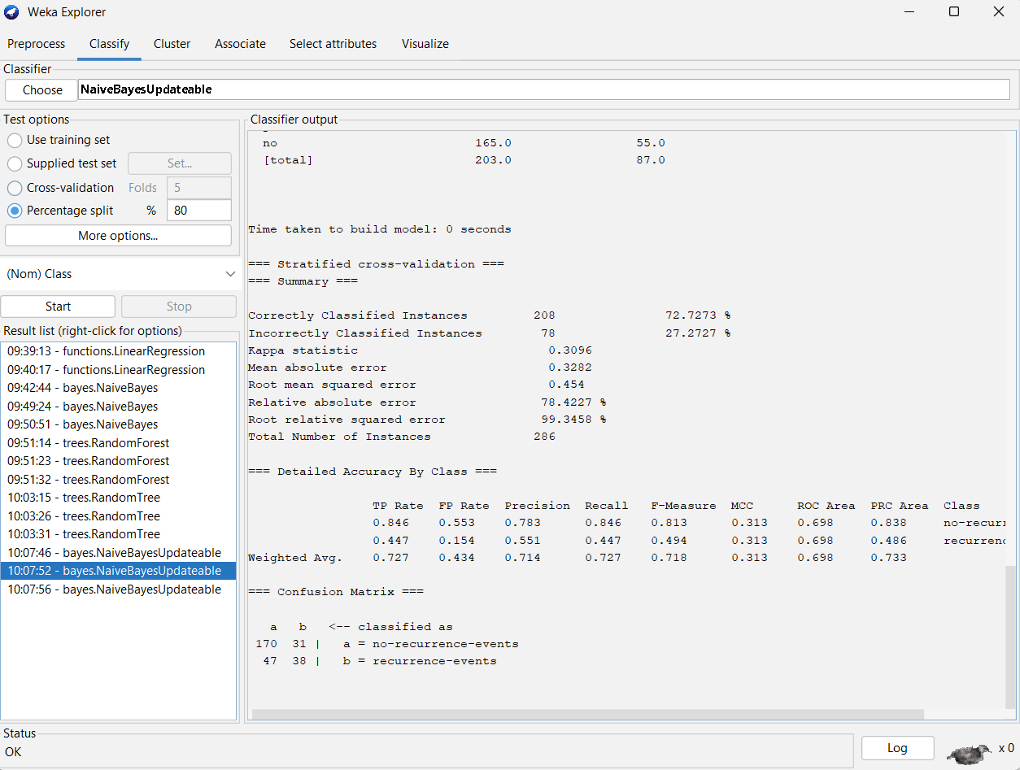

Naïve Bayse 80% split

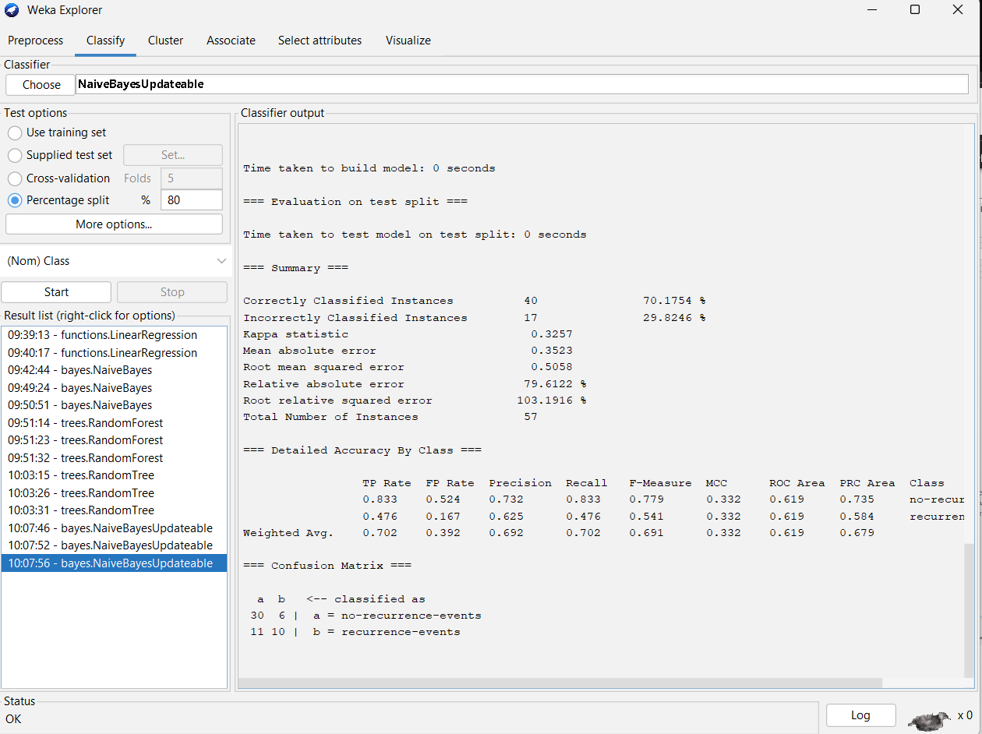

REP Tree 10 cross Validation

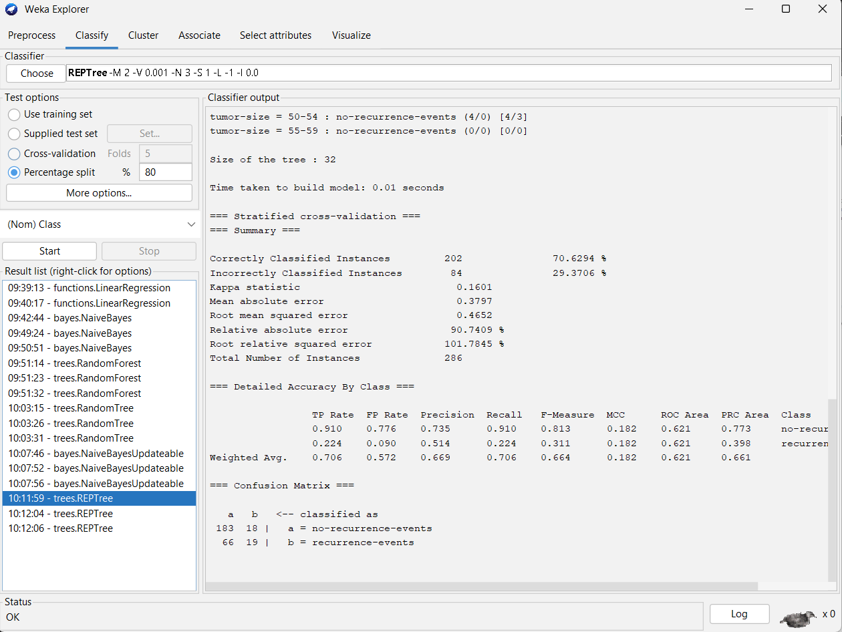

REP tree 5 cross validation

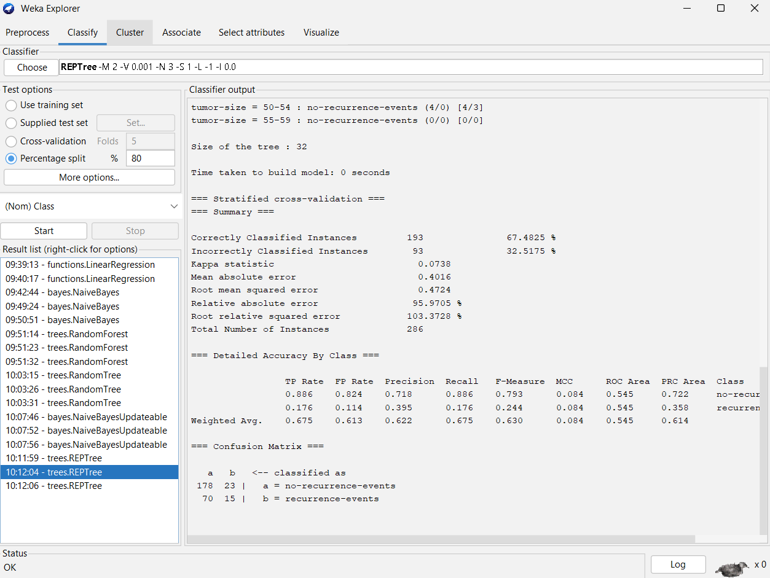

REP Tree 80% split

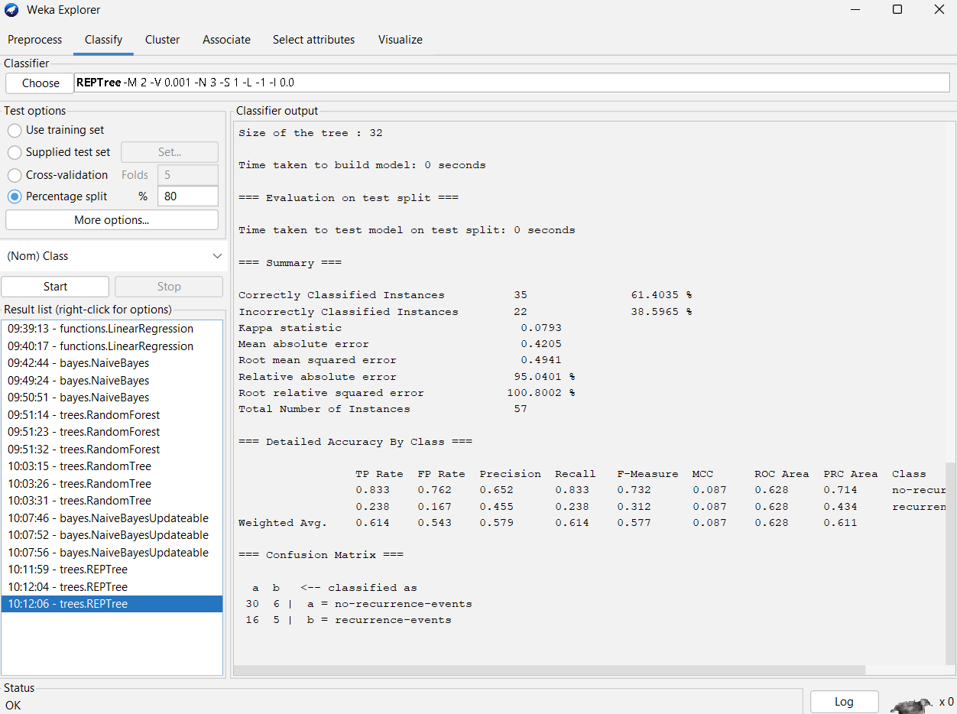

**Definitions:**

**TP Rate:** The proportion of correctly classified positive instances out of all actual positive instances.

**FP Rate**: The proportion of incorrectly classified negative instances out of all actual negative instances.

**Precision**: The proportion of correctly classified positive instances out of all instances classified as positive.

**Recall**: The proportion of correctly classified positive instances out of all actual positive instances (also known as True Positive Rate).

**F-measure**: The harmonic mean of precision and recall, providing a balance between the two metrics.

**MCC (Matthews Correlation Coefficient)**: A measure of the quality of binary classifications, considering true and false positives and negatives.

**ROC Area**: The area under the Receiver Operating Characteristic curve, representing the model's ability to distinguish between positive and negative classes.

**PRC Area**: The area under the Precision-Recall curve, highlighting the trade-off between precision and recall for different thresholds.